COURSE SYLLABUS

Course: MAN 4504 Operational Decision Making
Campus: West - Virtual
Semester/Term: Spring 2023
Prerequisites: 3353, 3240, and 3023
Credit Hours: 3
Class Meeting Day/Time: Virtual
Classroom:

Professor: Dr. Sean Newman
Email: snewman18@valenciacollege.edu
Office Phone:
Office: By Appointment
Office Hours: Please contact, by appointment

Course Description:
Operations and decisions by managers and staff are the critical pieces that make businesses work. You can have your strategy and your marketing, but without operations, the business will fail. If you advertise and excite customers about a product, but fail to deliver the product, you will quickly lose customers. There are a lot of examples of this in the business world.
This course focuses on operational decision-making management techniques to improve the processes and productivity in organizations. Discussions include quality and outcomes, efficiency, forecasting, workflow processes, inventory control, design of goods and services, waiting lines, and critical path. Managing a project from beginning to end, including how to identify needs, and define, assign, and track items is addressed.
This course is a study of operational decision-making techniques to improve the processes and productivity in organizations. Topics will include, but are not limited to, quality and outcomes, efficiency, forecasting, work-flow processes, inventory control, design of goods and services, waiting lines, critical path, and managing a project.
If you are unable to participate in the course due to illness, family emergency, etc., please communicate with me as soon as possible in order to create a plan to complete any missed assignments so that your learning can progress in your course. In the case of a prolonged online absence, please communicate with me as soon as possible in order to create a plan for the best course of action.
  - Course Major Learning Outcomes
- Discuss and analyze how operations and supply strategy relate to business process and success.
- Determine the critical path for a project.
- Apply decision trees to analyze alternatives.
- Develop and interpret break-even analyses.
- Apply waiting line (queuing) analysis to model common waiting line situations.
- Explain issues related to sourcing decisions.
- Explain issues related to locating business facilities.
- Discuss and apply “just in time” concepts.
- Assess different models to estimate demand.
- Demonstrate use of Gantt charts

  - Required Text:
Introduction to Operations Management: Operations Text Book

Course Organization:
This course will be divided into four categories that will comprise the final grade.

General Grading Scale:
A: 90-100
B: 80-89
C: 70-79
D: 60-69
F: 60-below

CLASSROOM POLICIES

Assignments
There are two longer assignment presentations posted in Canvas. Please follow instructions as posted.

  - Discussion Instructions (Initial Post is Require before “Viewing” Peer Posts): You are required to submit a substantial response. A substantial response is one that stays on topic and fully addresses the assignment in a clear, concise, and meaningful manner. Substantial Content refers to providing relevant content toward the actual topic of the discussions. This includes quality input, questions and information in your discussion posts and responses to peers.

The deliverable length of initial posting must be at least 150 words. After the initial posting, students are required to respond to at least two (2) peers’ responses. Peer responses must be at least 50 words for each response, in order to receive full credit. Discussions must be the student’s original thoughts based on the topics from the "Open Educational Resource" (OER) Course Textbook and/or other referenced sources. Direct quotes from references must be less than 10 words. Plagiarized discussions will result in a "0" for the submission of this assignment. Please review postings for sentence structure, grammar and punctuation errors. Late submissions are not accepted for discussions.

  - Discussion Posting Rules

- Personal attacks of other students because of their posts will not be tolerated.
- Provide clear analysis and insight into the topic or questions.
- Post original thoughts to avoid plagiarism and the penalties for plagiarism
- Zero or minimal credit will be given to students with very FEW or NO SUBSTANTIVE postings or who post all posts with in a matter of minutes or all on the last day.
- Proof postings to eliminate offensive references, poor sentence syntax, misspelled words, etc.

Exercises

Exercise Instructions: You are required to submit a minimum 3-Page (Title Page and Content Page), APA formatted paper with substantial content. Substantial content requires staying on topic and fully addresses the assignment in a clear, concise, and meaningful manner (examples or analysis). The deliverable length of your posting responses should be around 1 page of content, plus a title page in APA format. Please review your paper for grammar and punctuation errors.

Exercises must be the student’s original thoughts based on the topics from the "Open Educational Resource" (OER) Course Textbook and/or other referenced sources. Direct quotes from references must be less than 20 words. Plagiarized exercises may result in a "0" for the submission of this assignment. Please review postings for sentence structure, grammar and punctuation errors. Late submissions will be deducted 5 points.

Final Exercise Project - Course MAN4504
This paper is the final assignment in the course and is worth 100 points.
Write a paper reflecting on the top five things you learned in the course. The paper needs to be at least three full pages plus a title page, each of the five items/concepts need to be thoroughly explained in your own words, and you should include why you think these items/concepts are important. How have you applied these concepts in your personal/professional life and how might you use these concepts in your future?
Please do not just list five things and say they are important because you will need to know them in your career. I am looking for well-thought out and supported responses. Please attach your paper as a Microsoft Word document.
Course Schedule
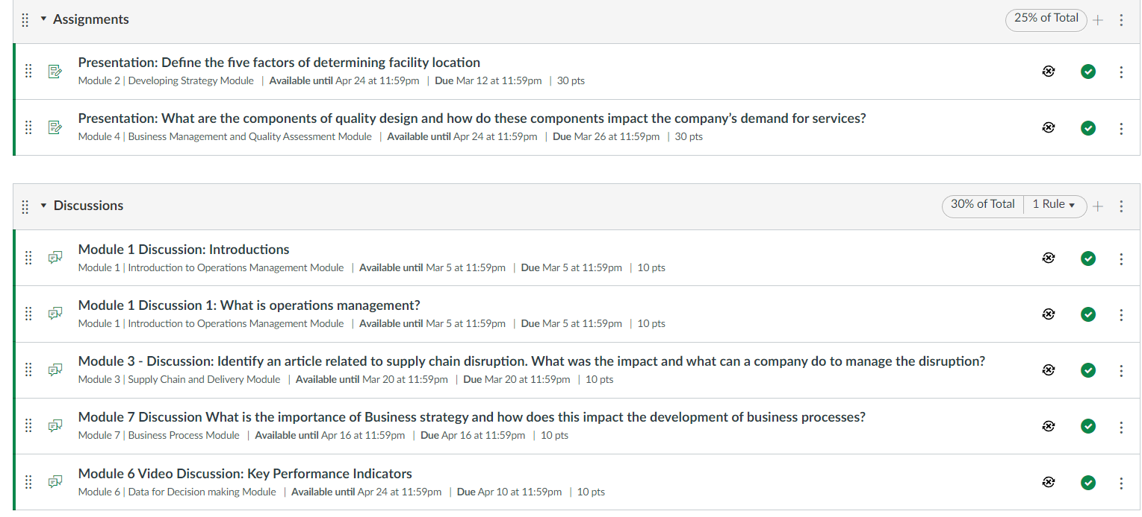
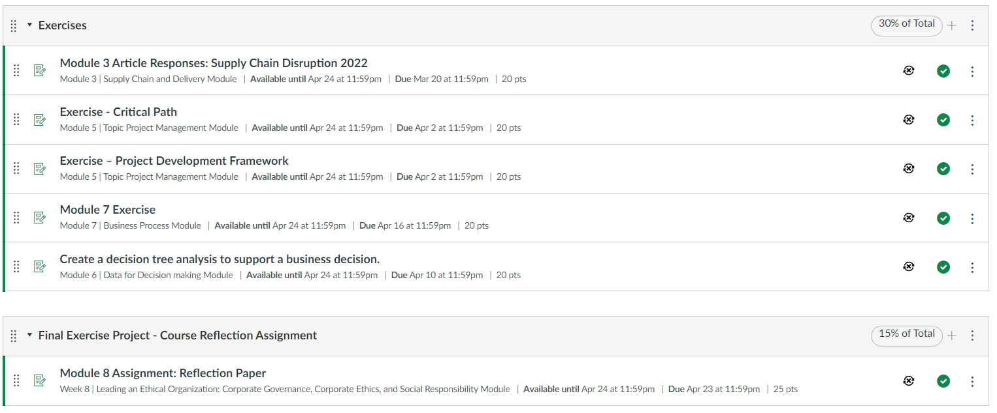

Distance Tutoring & Technology Support at Valencia:
You can easily access Valencia’s free distance tutoring and tech support from a computer, laptop or mobile device.
Distance tutoring services are provided fully online via Zoom. Through this service, you will receive real-time assistance via a Valencia tutor. Online tutoring is offered in: mathematics, sciences, accounting & economics, computer programming, EAP and foreign languages, and writing.
Online Learning Technology Support services are also available. Students can receive assistance with navigating: Canvas, OneDrive, Zoom, YouTube, and Microsoft Office (Word, Excel, & PowerPoint). Support is also provided for video editing (via iMovie and MovieMaker) and converting documents from a Mac to PC. Tech support is available live (on-demand) via Zoom, by appointment, or via email. Students are encouraged to use the 24/7 Canvas Help located inside Canvas by clicking on the “Help” icon.
To get started using the Distance Tutoring and Learning Technology Support services, please visit www.valenciacollege.edu/tutoring. Through this site, you can view the schedule of tutors/tech support assistants, find available times, learn more about the services, and access a collection of supplemental resources that are available 24/7.
Hours of Operation:
Monday-Friday: 8 am – 10 pm
Saturday & Sunday: 9 am – 7 pm
Online Tools:
As a Valencia student, you have access to Microsoft Word (as well as Microsoft Excel, Powerpoint, etc) free for personal use. You can learn more about accessing these applications in Atlas, on the "My Atlas" tab, right hand column, under "Microsoft Office for Personal Use."

Expected Student Conduct:
Valencia College is dedicated, not only to the advancement of knowledge and learning, but is concerned with the development of responsible personal and social conduct. By enrolling at Valencia College, a student assumes the responsibility of becoming familiar with and abiding by the general rules of conduct. The primary responsibility for managing the classroom environment rests with the faculty. Students who engage in any prohibited or unlawful acts that result in disruption of a classroom or Valencia’s rules may lead to disciplinary action up to and including expulsion from Valencia. Disciplinary action could include; being withdrawn from class, disciplinary warning, probation, suspension, expulsion or other appropriate and authorized actions. You will find the student code of conduct in the current Policy & Procedures Manual at http://www.valenciacollege.edu/generalcounsel/.

No show withdrawal: Valencia policy is that any student that does not come to class during our first two meetings will be withdrawn. The policy can be located at the following link: http://catalog.valenciacollege.edu/academicpoliciesprocedures/classattendance
For Online Attendance

For online attendance, students are required to log on weekly, review the week's course material and submit appropriate assignments/exams. Individual Assignments or Internet Assignments are due for each module of the online course. Attendance will be taken based on your submitting assignments weekly. If a student fails to submit an assignment when due, the student will be marked absent for that week.

Email Policy:
Students must have an active Atlas account. Students must check their Atlas e-mails regularly as to not miss any important messages from the professor. Missed messages via Atlas or any other medium (in-class, etc.) may affect your grade and are the responsibility of the student.

Academic Honesty:
Each student is expected to do his or her own work, unless otherwise specified. Cheating will not be tolerated and will result in an automatic “zero” on that exam or assignment. For obvious reasons, cell phones will not be permitted to be used as calculators or for any other reasons during exams. Anyone accessing their phone during an exam will receive an automatic zero for that exam. Students may not leave the classroom for any reason during exams.

Learning Support:
Distance Tutoring & Technology Support at Valencia: You can easily access Valencia’s free distance tutoring and tech support from a computer, laptop or mobile device.
Distance tutoring services are provided fully online via Zoom. Through this service, you will receive real-time assistance via a Valencia tutor. Online tutoring is offered in: mathematics, sciences, accounting & economics, computer programming, EAP and foreign languages, and writing.
Online Learning Technology Support services are also available. Students can receive assistance with navigating: Canvas, OneDrive, Zoom, YouTube, and Microsoft Office (Word, Excel, & PowerPoint). Support is also provided for video editing (via iMovie and MovieMaker) and converting documents from a Mac to PC. Tech support is available live (on-demand) via Zoom, by appointment, or via email. Students are encouraged to use the 24/7 Canvas Help located inside Canvas by clicking on the “Help” icon.

To get started using the Distance Tutoring and Learning Technology Support services, please visit www.valenciacollege.edu/tutoring. Through this site, you can view the schedule of tutors/tech support assistants, find available times, learn more about the services, and access a collection of supplemental resources that are available 24/7.
Hours of Operation:
Monday-Friday: 8 am – 10 pm
Saturday & Sunday: 9 am – 7 pm

Academic Accommodations:
“Students with disabilities who qualify for academic accommodations must provide a Notification to Instructor (NTI) form from the Office for Students with Disabilities (OSD) and discuss specific needs with the professor, preferably during the first two weeks of class. The Office for Students with Disabilities determines accommodations based on appropriate documentation of disabilities. See the appropriate office for more information:
- East Campus Bldg. 5, Rm. 216 Ph: 407-582-2229 Fax: 407-582-8908 TTY: 407-582-1222
- West Campus SSB, Rm. 102 Ph: 407-582-1523 Fax: 407-582-1326 TTY: 407-582-1222
- Osceola Campus Bldg. 1, Rm. 140A Ph: 407-582-4167 Fax: 407-582-4804 TTY: 407-582-1222
- Winter Park Campus Bldg. 1, Rm. 212 Ph: 407-582-6887 Fax: 407-582-6841 TTY: 407-582-1222

Student Assistance Program:
Valencia College is interested in making sure all our students have a rewarding and successful college experience. To that purpose, Valencia students can get immediate help with issues dealing with stress, anxiety, depression, adjustment difficulties, substance abuse, time management as well as relationship problems dealing with school, home or work. BayCare Behavioral Health Student Assistance program (SAP) services are free to all Valencia students and available 24 hours a day by calling (800) 878-5470. This number is also located on the back of your Valencia Student ID. Free face to face counseling is also available.

Note to International Students (F-1 or J-1 Visa)
Please be advised that withdrawal from this course due to attendance may result in the termination of your visa status if you fall below the full-time enrollment requirement of 12 credit hours. Contact Valencia’s International Student Services office for more information.

Statement of Support for Students with Food/Housing/Financial Needs
Any student who has difficulty accessing sufficient food to eat, or who lacks a safe and stable place to live, and believes this may affect his or her performance in the course, is urged to meet with a Counselor in the Advising Center for information about resources that may be available from the college or community.

Withdrawal Policy:
The withdrawal policy deadline for the semester – See Academic Calendar “Important Dates & Deadlines” http://valenciacollege.edu/calendar/

A student who withdraws from class before the established deadline for a particular term will receive a grade of “W”. A student is not permitted to withdraw after the withdrawal deadline. After this date, the grade assigned will be based on the student’s academic achievement in class and the actual work completed.

Institutional Core Competencies:
The following Valencia Student Competencies will be reinforced throughout the entire course:
- THINK – Analyze data, ideas, patterns, principles, and perspectives employing facts, formulas and procedures of the discipline.
- VALUE – Distinguish among personal, ethical, aesthetic, cultural, and scientific values evaluating your own and others values from a global perspective in the process of learning the discipline.
- COMMUNICATE – Identify your own strengths and need for improvement as a communicator employing methods of communication appropriate to your audience and purposefully evaluate the effectiveness of your own and others communication.
- ACT – Apply disciplinary knowledge, skills, and values to educational and career goals acting effectively and appropriately in various personal and professional settings responding also to changing circumstances.
Engagement (Office) Hours and Service to the College Opportunities for the upcoming term (Full-time)
Student engagement (office) hours
- Engagement hours for all classes are virtual
- Faculty who have a course meeting on-site MAY choose to have some or all of their student engagement hours on-site in the same building where the class is taught (to avoid opening additional buildings and facilities)
- Faculty who are interested in holding on-site engagement hours should contact their dean
Service to the College opportunities, consider:
- Continued development of online teaching practice
- Equity-minded practices development and work
- Impact plan
- Other work team/committee opportunities

Disclaimer:
Changes in this syllabus, schedule, and or college policy may be made at any time during the course per instructor discretion. Students are responsible for staying abreast of these changes.
Students are responsible for staying abreast of these changes.

